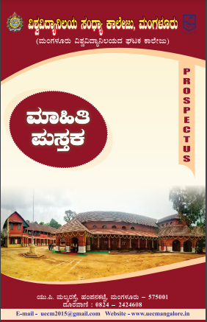
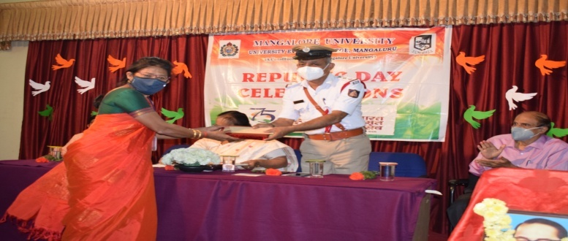
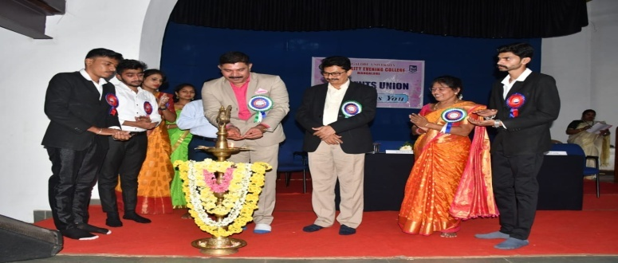

UÀtgÁeÉÆåÃvÀìªÀ PÁAiÀÄðPÀæªÀÄ
«zÁåyð ¸ÀAWÀzÀ GzÁÏl£Á PÁAiÀÄðPÀæªÀÄ- 2021

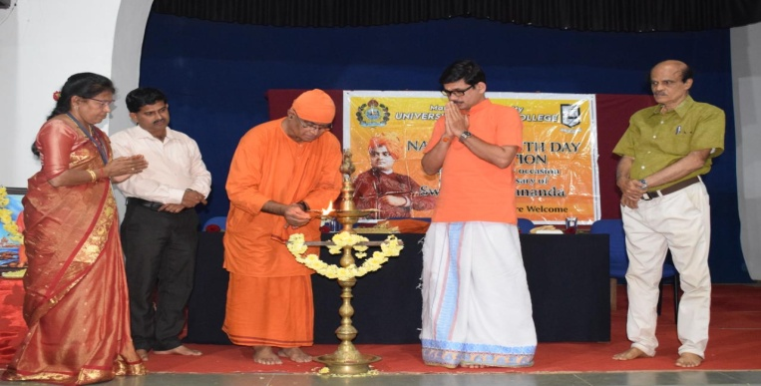
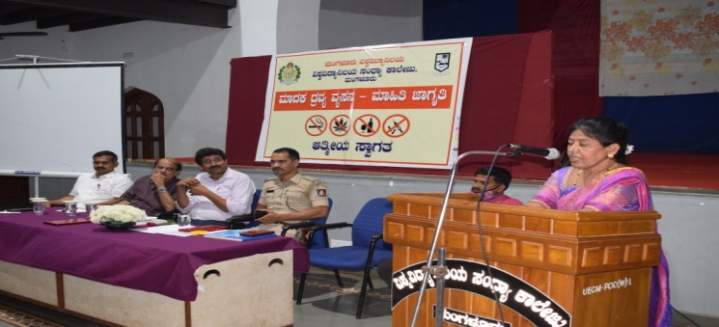

¸Áé«Ä «ªÉÃPÁ£ÀAzÀgÀ d£Àä¢£ÁZÀgÀuÉAiÀÄ PÁAiÀÄðPÀæªÀÄ
ªÀiÁzÀPÀ zÀæªÀå ªÀå¸À£À – ªÀiÁ»w eÁUÀÈw PÁAiÀÄðPÀæªÀÄ
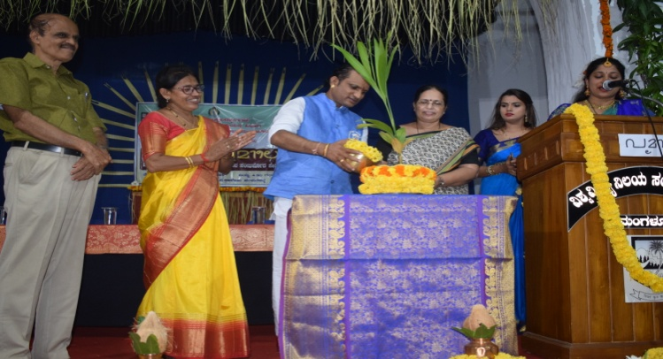
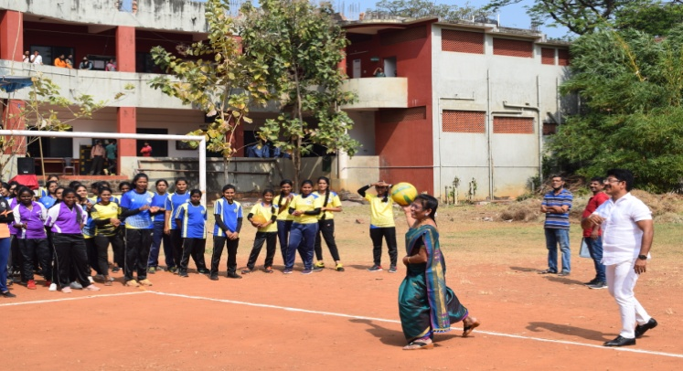

PÀ£ÁðlPÀ vÀÄ¼ÀÄ ¸Á»vÀå CPÁqÉ«ÄAiÀÄ “¥ÀÆªÀiÁ¯É”
PÁAiÀÄðPÀæªÀÄ
CAvÀgÀ PÁ¯ÉÃdÄ ªÀÄ»¼Á xÉÆæÃ- ¨Á¯ï ¥ÀAzÁåªÀ½

PÁ¯ÉÃf£À «ªÀgÀUÀ¼ÀÄ
ºÉ¸ÀgÀÄ
«±Àé«zÁå¤®AiÀÄ ¸ÀAzsÁå PÁ¯ÉÃdÄ, ªÀÄAUÀ¼ÀÆgÀÄ
(ªÀÄAUÀ¼ÀÆgÀÄ «±Àé«zÁå¤®AiÀÄ WÀlPÀ PÁ¯ÉÃdÄ)
¸ÁÜ¥À£É : 2015
«¼Á¸À
AiÀÄÄ.¦. ªÀÄ®å gÀ¸ÉÛ, ºÀA¥À£ÀPÀmÉÖ, ªÀÄAUÀ¼ÀÆgÀÄ – 575001
zÀÆgÀªÁtÂ : 0824 – 2424608
E-mail - uecm2015@gmail.com
Website – www. uecmangalore.in

DqÀ½vÀ
ªÀÄAUÀ¼ÀÆgÀÄ «±Àé«zÁå¤®AiÀÄ
ªÀÄAUÀ¼ÀUÀAUÉÆÃwæ, zÀ.PÀ – 574199

¥ÉÆæ. ¦. ¸ÀÄ§æºÀätå AiÀÄqÀ¥ÀrvÁÛAiÀÄ
PÀÄ®¥ÀwUÀ¼ÀÄ
ªÀÄAUÀ¼ÀÆgÀÄ «±Àé«zÁå¤®AiÀÄ
qÁ. Q±ÉÆÃgï PÀÄªÀiÁgï ¹.PÉ
PÀÄ®¸ÀaªÀgÀÄ
ªÀÄAUÀ¼ÀÆgÀÄ «±Àé«zÁå¤®AiÀÄ
qÁ. ¸ÀÄ¨sÁ¶tÂ ²æÃªÀvÀì
¥ÁæA±ÀÄ¥Á®gÀÄ
«±Àé«zÁå¤®AiÀÄ ¸ÀAzsÁå PÁ¯ÉÃdÄ, ªÀÄAUÀ¼ÀÆgÀÄ
«±Àé«zÁå¤®AiÀÄ ¸ÀAzsÁå PÁ¯ÉÃdÄ, ªÀÄAUÀ¼ÀÆgÀÄ

zsÉåÃAiÀÄ/Vision
¸ÀªÀiÁdzÀ J¯Áè ªÀUÀðzÀ «zÁåPÁAQëUÀ½UÉ eÁÕ£ÀzÀ PÉÃAzÀæªÁUÀÄªÀÅzÀÄ.
To be the Centre for knowledge to all sections of the society

zsÉåÃAiÀÄªÁPÀå/Vision Statement
¤AiÀÄvÀA PÀÄgÀÄ PÀªÀÄð
¤£Àß PÀvÀðªÀåªÀ£ÀÄß ¤AiÀÄvÀªÁV ªÀiÁqÀÄ
Perform your duty without fail

Mission Statement
¥ÀæwAiÉÆ§â£ÉÆ¼ÀVgÀÄªÀ CzÀªÀÄå ZÉÃvÀ£ÀªÀ£ÀÄß eÁUÀÈvÀUÉÆ½¹ vÀ£ÀÆä®PÀ
ªÀiÁ£ÀªÀ fÃªÀ£ÀªÀ£ÀÄß CxÀð¥ÀÆtðUÉÆ½¸ÀÄªÀ ¢QÌ£À°è ¤µÉ×¬ÄAzÀ
¤gÀAvÀgÀ PÀvÀðªÀå ªÀiÁqÀÄªÀÅzÀÄ
Activating the dormant spirit deep down in an
Individual thereby enabling one to lead a meaningful
And purposeful life
C¨sÀåyðUÀ¼ÀÄ ªÀÄvÀÄÛ ºÉvÀÛªÀgÀ UÀªÀÄ£ÀPÉÌ

ªÀÄAUÀ¼ÀÆj£À «±Àé«zÁå¤®AiÀÄ PÁ¯ÉÃf£À DªÀgÀtzÀ°è ºÉÆ¸ÀzÁV «±Àé«zÁå¤®AiÀÄ ¸ÀAzsÁå PÁ¯ÉÃd£ÀÄß ±ÉÊPÀëtÂPÀ ªÀµÀð 2015 gÀ°è ¥ÁægÀA©ü¸À¯ÁVzÀÄÝ, F PÁ¯ÉÃf£À°è J¯Áè ªÀUÀðUÀ¼À «zÁåyðUÀ¼À ¸ÀªÀðvÉÆÃªÀÄÄR ¨É¼ÀªÀtÂUÉUÉ CªÀPÁ±À«zÀÄÝ, J¯Áè ¸ÀÛgÀUÀ¼À «zÁåyðUÀ½UÉ ºÀUÀ®Ä ºÉÆvÀÄÛ vÀªÀÄä GzÉÆåÃUÀ ªÁå¥ÁgÀzÉÆA¢UÉ ¸ÀAeÉ ºÉÆwÛ£À°è G£ÀßvÀ ²PÀëtPÉÌ CªÀPÁ±À PÀ°à¸ÀÄªÀ ¤nÖ£À°è ¸ÀAzsÁå PÁ¯ÉÃd£ÀÄß ¥ÁægÀA©ü¸À¯ÁVzÉ. F PÁ¯ÉÃf£À°è «zÁåyðUÀ½UÉ PÀ°PÉUÉ ¨ÉÃPÁzÀ ªÁvÁªÀgÀtªÀ£ÀÄß ¤ªÀiÁðt ªÀiÁqÀ®Ä «±Àé«zÁå¤®AiÀÄ ¸ÀªÀðjÃwAiÀÄ £ÉgÀªÀ£ÀÄß ¤ÃqÀÄwÛzÉ. PÉÃªÀ® PÀ°PÉ ªÀiÁvÀæªÀ®èzÉ «zÁåyðUÀ¼À ¸ÀÈd£À²Ã® ¥Àæw¨sÉAiÀÄ£ÀÄß ¥ÀæPÀl¥Àr¸À®Ä ªÀÄvÀÄÛ ªÀ¢üð¸À®Ä PÁ¯ÉÃf£À°è CªÀPÁ±À PÀ°à¸À¯ÁVzÉ. PÁ¯ÉÃf£À°è CvÀåAvÀ ªÀåªÀ¹ÜvÀªÁzÀ UÀæAxÁ®AiÀÄ«zÀÄÝ «zÁåyðUÀ¼À eÁÕ£ÀzÁºÀªÀ£ÀÄß ¤ÃV¸À®Ä ¸ÀºÀPÁjAiÀiÁVzÉ. ¥ÀæªÉÃ±ÀPÉÌ ¸ÀA§A¢ü¹zÀAvÉ «±Àé«zÁå¤®AiÀÄzÀ ¤zÉÃð±À£ÀzÀAvÉ ºÁUÀÆ ¸ÀgÀPÁgÀzÀ ¤AiÀÄªÀiÁªÀ½UÀ¼ÀAvÉ «zÁåyðUÀ¼À£ÀÄß DAiÉÄÌ ªÀiÁqÀ¯ÁUÀÄvÀÛzÉ. F ¸ÀA¸ÉÜUÉ ¥ÀæªÉÃ±À ¥ÀqÉAiÀÄ®Ä vÀªÀÄUÉ ºÀÈvÀÆàªÀðPÀªÁzÀ ¸ÁéUÀvÀ. PÁ¯ÉÃfUÉ ¥ÀæªÉÃ±À zÉÆgÀQzÀ°è E°è£À ¤AiÀÄªÀiÁªÀ½AiÀÄ CrAiÀÄ°è «zÁåyðUÀ¼À £ÀqÀvÉ EgÀ¨ÉÃPÀÄ. ²¸ÀÄÛ ªÀÄvÀÄÛ PÀ°PÉUÉ PÁ¯ÉÃf£À°è DzÀåvÉ ¤ÃqÀ¯ÁUÀÄvÀÛzÉ. Cfð £ÀªÀÄÆ£ÉAiÀÄ£ÀÄß ¸ÀªÀÄ¥ÀðPÀªÁV ¨sÀwð ªÀiÁr ¤UÀ¢AiÀiÁzÀ ¢£ÀzÀAzÀÄ ¸À°è¹ ¤UÀ¢AiÀiÁzÀ ¢£ÀzÀAzÀÄ PÀZÉÃjUÉ ¸À°è¹ ¥ÀæªÉÃ±À ¥ÀqÉAiÀÄ¨ÉÃPÀÄ.

qÁ. ¸ÀÄ¨sÁ¶tÂ ²æÃªÀvÀì
¥ÁæA±ÀÄ¥Á®gÀÄ

MANGALORE UNIVERSITY

Regulations Governing the Choice Based Credit System Semester Scheme with Multiple Entry and Exit Options in the Undergraduate and Post-graduate Degree Programmes in the Faculties of Arts, Science and Commerce
(Framed under Section 44 (1) (c) of the KSU Act 2000)

Salient Features of the Four Years Multidisciplinary Undergraduate Programmes
  - The programme shall be structured in a semester mode with multiple exit options with Certificate, Diploma and Basic Bachelor Degree at the completion of first, second and third years, respectively. The candidate who completes the four years Undergraduate Programme, would get a Bachelor’s degree with Honours.

  - The four years undergraduate Honours degree holders with research component and a suitable grade are eligible to enter the ‘Doctoral (Ph.D.) Programme’ in a relevant discipline or to enter ‘Two Semester Master’s Degree programme with project work’.

  - Candidates who wish to enter the master’s/doctoral programme in a discipline other than the major discipline studied at the undergraduate programmes, have to take additional courses in the new discipline to meet the requirement or to make up the gap between the requirement and the courses already studied.

  - There may be parallel five year integrated masters degree programmes with exit options at the completion of third and fourth years, with the undergraduate degree and undergraduate degree with honours in a discipline, respectively.
  - The Multidisciplinary Undergraduate Programme may help in the improvement of all the educational outcomes, with a flexible and imaginative curricular approach. The programme provides for both breadth and depth in diverse areas of knowledge. A range of courses are offered with rigorous exposure to multiple disciplines and areas, while specializing in one or two areas. The programme fulfils knowledge, vocational, professional and skill requirements along-side humanities and arts, social, physical and life sciences, mathematics, sports etc.

  - The curriculum combines conceptual knowledge with practical engagement and understanding that has relevant real world application through practical laboratory work, field work, internships, workshops and research projects.

  - A few courses are common to all students which contribute to the breadth of study and two areas of specialization in disciplinary areas provides for depth of study.

  - The areas of specialization which the students are required to choose are either two disciplines/ subjects or a discipline called ‘major’ (e.g. History or Economics or Physics or Mathematics) and an area of additional discipline called ‘minor’ (e.g. Music or Sports or Geography). Students gain deep disciplinary knowledge through theory and practical experiences in their area of specialization (major). They gain a reasonable understanding of the area of additional study (minor) that they choose. Students can choose subject combinations across ‘streams’ (e.g. a student can choose a ‘major’ in physics and combine it with a ‘minor’ in history or Music or Sports). One of the disciplines can also be a vocational subject or Teacher Education.

  - The students may study two disciplines at the same level or breadth up to the sixth semester and choose one of them for study in the fourth year to obtain the Honours degree in that discipline. A student who wishes to get dual honours degrees may repeat the fourth year of the program in the second discipline.

  - The students may choose one discipline and vocational subject or Teacher Education for their study in the undergraduate programme. This will enable them to get an Honours degree either in the discipline or in the vocational subject/ Teacher Education or both, in the discipline and in the vocational subject/ Teacher Education.

  - Skills shall be explicitly integrated, highly visible, taught in context, and have explicit assessment. The skills shall include abilities in language and communication, working in diverse teams, critical thinking, problem solving, data analysis and life skills.

  - Students shall be given options to choose courses from a basket of courses which the institution is offering. There shall be no rigidity of combination of subjects.

The Four-Year Choice Based Credit System Semester Scheme makes the product of a University at par with the global practices in terms of academic standards and evaluation strategies. In the emerging scenario of Internationalization of Indian Higher Education, it is imperative that the Universities in India should follow this system so that the mobility of their products both within and across the geographical jurisdiction becomes possible.
The Salient Features of the Credit Based Semester Scheme:
Each course shall carry certain number of credits. Credits normally represent the weightage of a course and are a function of teaching, learning and evaluation strategies such as the number of contact hours, the course content, teaching methodology, learning expectations, maximum marks etc. In the proposed programmes, generally one hour of instructions per week in a semester is assigned one credit. In terms of evaluation, one credit is generally equivalent to 25 marks in a semester. Thus a 3 or 4 credits course will be assessed for 100 marks, 2 credits courses are assessed for 50 marks and one credit course will be assessed for 25 marks. What matters for the calculation of Semester Grade Point Average (SGPA) or the Cumulative Grade Point Average (CGPA) is the percentage of marks secured in a course and the credits assigned to that course.
On this basis, generally, a three-year six-semester undergraduate programme will have around 140 credits, and a four-year eight-semester honors degree programme will have around 180 credits and a five-year ten-semester master’s degree programme will have 220 credits.
. The general features of the Credit Based Semester Scheme are
- The relative importance of subjects of study are quantified in terms of credits.
- The subjects of study include core, elective, ability/skill enhancement courses
- The programme permits horizontal mobility in course selections.
- The students shall take part in co-curricular and extension activities.
- The declaration of result is based on Semester Grade Point Average (SGPA) or Cumulative Grade Point Average (CGPA) earned.

Definitions of Key Words:
- Academic Year: Two consecutive (one odd + one even) semesters constitute one academic year.
- Choice Based Credit System (CBCS): The CBCS provides choice for students to select courses from the prescribed courses (core, open elective, discipline elective, ability and skill enhancement language, soft skill etc. courses).
- Course: Usually referred to as ‘paper’, which is a component of a programme. All courses need not carry the same weight. The courses should define learning objectives and learning outcomes. A course may be designed to comprise lectures/ tutorials/laboratory work/ field work/ project work/ vocational training/viva/ seminars/term papers / assignments/ presentations/ self-study etc. or a combination of some of these.
- Credit Based Semester System (CBSS): Under the CBSS, the requirement for awarding a degree /diploma /certificate is prescribed in terms of number of credits to be earned.
- Credit: A unit by which the course work is measured. It determines the number of hours of instructions required per week in a semester. One credit is equivalent to one hour of lecture or tutorial or two hours of practical work/field work per week in a semester. It will be generally equivalent to 13-15 hours of instructions per semester.
- Grade Point: It is a numerical weight allotted to each letter grade on a 10-point scale.
- Credit Point: It is the product of grade point and number of credits for a course.
- Letter Grade: It is an index of the performance of students in a said course. Grades are denoted by letters O, A+, A, B+, B, C, P and F.
- Programme: It is a study in a discipline leading to award of a Degree, diploma or certificate.
- Semester: Each semester will consist of over 16 weeks of academic work equivalent to 90 actual teaching days. The odd semester may be generally scheduled from June to November and even semester from January to May.
- Semester Grade Point Average (SGPA): It is a measure of performance of work done in a semester. It is the ratio of total credit points secured by a student in various courses registered in a semester and the total course credits taken during that semester. It shall be expressed up to two decimal places.
- Cumulative Grade Point Average (CGPA): It is a measure of overall cumulative
performance of a student over all the semesters of a programme. The CGPA is the ratio of total credit points secured by a student in various courses in all the semesters and sum of the total credits of all courses in all the semesters. It is expressed up to two decimal places.
- Transcript or Grade Card or Certificate: Based on the grades earned, a Grade Card shall be issued to all the registered students after every semester. The grade certificate will display the course details (code, title, number of credits, grade secured etc.).

PROGRAMMES:

Faculty of Arts:
Bachelor of Arts, B.A., Bachelor of Arts with Honors, B.A.(Hons.), Integrated Master of Arts, M.A.(Integrated) and Master of Arts, M.A. in various Disciplines/ Subjects.

Faculty of Science
Bachelor of Computer Applications, BCA, Bachelor of Computer Applications with Honors, BCA (Hons.), Integrated Master of Computer Applications, MCA(Integrated) and Master of Computer Applications, MCA.

Faculty of Commerce
Bachelor of Commerce, B.Com., Bachelor of Commerce with Honors, B.Com.(Hons. Integrated Master of Commerce, M.Com.(Integrated) and Master of Commerce, M. Com or MBA.

DURATION OF PROGRAMMES, CREDITS REQIUREMENTS AND OPTIONS:
The undergraduate degree should be of either a three- or four-year duration, with multiple entry and exit options within this period, The four years multidisciplinary Bachelor’s programme is the preferred option as it allows the opportunity to experience the full range of holistic and multidisciplinary education with a focus on major and minor subjects as per the student’s preference. The four-year programme may also lead to a degree with Research, if the student completes a rigorous research project in the major area(s) of study.

The undergraduate programmes shall extend over four academic years (Eight Semesters) with multiple entry and exit options. The students can exit after the completion of one academic year (two semesters) with the Certificate in a discipline or a field; Diploma after the study of two academic years (four Semesters) and Regular Bachelor Degree after the completion of Three academic years (six Semesters). The successful completion of Four Years undergraduate Programme would lead to Bachelor Degrees with Honors in a discipline/subject. Each semester shall consist of at least 16 weeks of study with a minimum of 90 working days (excluding the time spent for the conduct of end semester examinations).

The candidates shall complete the courses equivalent to minimum credit requirements

Exit with | Minm Credits  Requirement* | NSQF  Level
Certificate at the Successful Completion of First Year (Two  Semesters) of Four Years Multidisciplinary UG Degree Programme | 48 | 5
A Diploma at the Successful Completion of the Second Year (Four  Semesters) of Four Years Multidisciplinary UG Degree Programme | 96 | 6
Basic Bachelor Degree at the Successful Completion of the Third Year (Six Semesters) of Four Years Multidisciplinary  Undergraduate Degree Programme | 140 | 7
Bachelor Degree with Honours in a Discipline at the Successful  Completion of the Four Years (Eight Semesters) Multidisciplinary Undergraduate Degree Programme | 180 | 8
*Details of courses to be successfully completed equal to minimum credits requirements are described later

The students shall be required to earn at least fifty per cent of the credits from the Higher Education Institution (HEI) awarding the degree or diploma or certificate: Provided further that, the student shall be required to earn the required number of credits in the core subject area necessary for the award of the degree or Diploma or Certificate, as specified by the degree awarding HEI, in which the student is enrolled.
A candidate who successfully completes a three year Bachelor’s degree, with a minimum CGPA of 7.5 and wishes to pursue the fourth year of the undergraduate programme by research, shall be allowed to continue the programme with Research to obtain the Bachelor’s degree with honors by research, while other candidates may continue their studies in the fourth year of the undergraduate programme with or without a research project along with other courses as prescribed for the programme to complete their Bachelor’s degree with honors.

Candidates who successfully complete their four years Bachelor’s degree with honors, either by research or course work with research component and a suitable grade are eligible to enter the ‘Doctoral (Ph.D.) Programme’ in a relevant discipline or to enter the ‘Two Semester Master’s Degree programme”.

Candidates who wish to complete the undergraduate and the postgraduate programmes faster, may do so by completing the different courses equal to the required number of credits and fulfilling all other requirements in N-1 semesters (where N is the number of semesters of an undergraduate/ postgraduate programme). This facility is available for the programmes with a minimum duration of three years or six semesters. For example, a candidate may obtain his/her Six Semesters Bachelor’s degree, after successfully completing five semesters of the programme, provided he/she has completed courses equal to the required/ prescribed number of credits and fulfills all other requirements for awarding the degree. Likewise, a candidate may obtain his/her Eight Semesters Bachelor’s degree with honors, after successfully completing seven semesters of the programme, provided he/she has completed courses equal to the required number of credits and fulfills all other requirements for awarding the Bachelor’s degree with honours.

Similarly, candidates may complete both the undergraduate and the postgraduate programmes in slow track. They may pursue the three years or six semester programmes in 4 to 5 years (8 to 10 semesters) and four years or eight semester programmes in 5 to 6 years (10 to 12 semesters). As a result, the higher education institutions have to admit candidates not only for programmes, but also for subjects or courses. But the new admissions are generally made in the beginning of an academic year or the beginning of odd semesters.

National Skills Qualifications Framework
The National Skills Qualifications Framework (NSQF) is a competency-based framework that organizes qualifications according to a series of knowledge, skills and aptitude. The NSQF levels, graded from one to ten, are defined in terms of learning outcomes which the learner must possess regardless of whether they are obtained through formal, non-formal or informal learning. National Occupational Standards (NOS) are statements of the skills, knowledge and understanding needed for effective performance in a job role and are expressed as outcomes of competent performance. They list down what an individual performing that task should know and also are able to do. These standards can form the benchmarks for various education and training programmes to match with the job requirements. Just as each job role may require the performance of a number of tasks, the combination of NOSs corresponding to these tasks form the Qualification Pack (QP) for that job role. The NOSs and QPs for each job role corresponding to each level of the NSQF are being formulated by the respective Sector Skill Councils (SSCs) set up by National Skill Development Corporation (NSDC) with industry leadership. The curriculum which is based on NOSs and QPs would thus automatically comply with NSQF.

General Education has to be synchronized/ aligned with skill and Vocational Education as per National Skills Qualifications Framework. The level descriptors are given below as described in UGC Guidelines on National Skills Qualifications Framework. The curriculum should be designed in a manner that at the end of year-1, year-2 and year-3, students are able to meet below mentioned level descriptors for level 5, 6 and 7 of NSQF, respectively: The progressive curriculum proposed shall position knowledge and skills required on the continuum of novice problem solvers (at entry level of the programme) to expert problem solvers (by the time of graduation):

At the end of first year – Ability to solve well defined problems
At the end of second year – Ability to solve broadly defined problems
At the end of third year – Ability to solve complex problems that are ill-structured requiring multi-disciplinary skills to solve them
During fourth year- Experience of workplace problem solving in the form of Internship or Research Experience preparing for
Higher Education or Entrepreneurship Experience

Levels | Process required | Professional knowledge | Professional skill | Core skill | Responsibility
Level 5 | Job that requires  well developed | Knowledge of  facts, principles, | A range of cognitive and  practical skills required to | Desired mathematical  skill,understanding of | Responsibility for  own work and
 | skill, with clear | processes and | accomplish tasks and | social, political and | learning & some
 | choiceof procedures | general concepts, | solve problems by | some skill of collecting | responsibility for
 | in familiar context | in a field of work | selecting and applying | and organizing | other’s works and
 |  | or study | basic methods, tools | information, | learning
 |  |  | materials and information | communication.
Level 6 | Demands wide range of specialized  technical skill,  clarity of knowledge and practice in broad range of activity involving standard / non- standard practices | Factual and  Theoretical knowledge in broad contexts  within a field of work or study | A range of cognitive  and practical skills required to generate solutions to specific  problems in a field of work or study | Reasonably good in  Mathematical calculation, Understanding of social, political and, reasonably good in data collecting organizing information,  and logical communication | Responsibility  for own work and learning and full  responsibilityfor other’s works and learning
Level 7 | Requires a command of wide ranging specialized theoretical and practical skill, involving variable routine and nonroutine context | Wide ranging, factual and theoretical knowledge in broad contexts within a field of work or study | Wide range of  cognitive and practical skills required to  generate solutions to specific problems in a field of work or study | Good logical and  mathematical skill; understanding of Social, political and natural environment; ability in collectingand organizing information, communication and  presentation skill | Full  responsibility for output of group and development

Professional knowledge is what a learner should know and understand with reference to the subject;
Professional skills are what a learner should be able to do and; Core skills refer to basic skills involving dexterity and use of methods, materials,tools and instruments used to perform the job including IT skills needed for that job and Responsibility aspect determines the (i) nature of working relationship, (ii) level of responsibility for self and others, (iii) managing change and (iv) accountability for actions.
The Integrated Master’s Degree Programmes shall extend over Five academic years (Ten Semesters) with exit options with Bachelor Degree after successful completion of Three academic years (Six Semesters) of study and Bachelor Degree with Honours in a discipline/ subject at the end of Four academic years (Eight Semesters). Completion of five years of Integrated Programme would lead to Masters degree in a subject.

Credit Requirements:
The candidates shall complete courses equivalent to a minimum of 140 credits to become eligible for the Regular Bachelor Degree, 180 credits to become eligible for the Bachelor Degree with Honors 220 credits to become eligible for the Integrated Master’s Degree.

Master’s Degree Programmes will be of One Academic Year (Two Semesters)
for the Four Years Honors Degree holders and it will be of Two Academic Years (Four Semesters) for the three years basic or three years Honors Degree holders.
Two Years Master’s Degree Programmes will have exit option at the end of One Academic Year (Two Semesters) with the Post-graduate Diplomas in the respective disciplines/ subjects, provided they complete courses equal to a minimum of 44 credits:.

44 Credits after the Bachelor Degree to become eligible for the PG Diploma
88 Credits after the Bachelor Degree to become eligible for the Masters Degree

It is optional to the candidate to exit or not, after two, four and six semesters of the undergraduate programme with Certificate, Diploma and with Regular Bachelor Degree, respectively. He/she will be eligible to rejoin the programme at the exit level to complete either the diploma, degree or the honors degree. Further, all the candidates will be awarded Bachelor degrees on successful completion of Three academic years (Six Semesters) of the undergraduate programmes.

ACADEMIC BANK OF CREDITS (ABC)
The Academic Bank of Credits (ABC), a national-level facility will promote the flexibility of the curriculum framework and interdisciplinary/multidisciplinary academic mobility of students across the Higher Education Institutions (HEIs) in the country with appropriate “credit transfer” mechanism. It is a mechanism to facilitate the students to choose their own learning path to attain a Degree/ Diploma/Certificate, working on the principle of multiple entry and exit as well as anytime, anywhere, and any level of learning. ABC will enable the integration of multiple disciplines of higher learning leading to the desired learning outcomes including increased creativity, innovation, higher order thinking skills and critical analysis. ABC will provide significant autonomy to the students by providing an extensive choice of courses for a programme of study, flexibility in curriculum, novel and engaging course options across a number of higher education disciplines/ institutions.

The multiple entry and exit options for students is facilitated at the undergraduate and Master’s levels. It would facilitate credit accumulation through the facility created by the ABC scheme in the “Academic Bank Account” opened for students across the country to transfer and consolidate the credits earned by them by undergoing courses in any of the eligible HEIs. The ABC allows for credit redemption through the process of commuting the accrued credits in the Academic Bank Account maintained in the ABC for the purpose of fulfilling the credits requirements for the award of certificate/ diploma/degree by the authorized HEIs. Upon collecting a certificate, diploma or degree, all the credits earned till then, in respect of that certificate, diploma or degree, shall stand debited and deleted from the account concerned. HEIs offering programmes with the multiple entry and exit system need to register in the ABC to enable acceptance of multidisciplinary courses, credit transfer, and credit acceptance.

The validity of credits earned will be for a maximum period of seven years or as specified by the Academic Bank of Credits (ABC). The procedure for depositing credits earned, its shelf life, redemption of credits, would be as per UGC (Establishment and Operationalization of ABC scheme in Higher Education) Regulations, 2021.

ELIGIBILITY FOR ADMISSIONS:
- B.A. Programme
A candidate who has passed the two years Pre-University Examination conducted by the Karnataka Pre-University Education Board or any other examination considered as equivalent thereto shall be eligible for admission to this programme

- B.C.A. Programme

A candidate who has passed the two years Pre-University Examination conducted by the Pre-University Education Board in Karnataka or JODC / Three years Diploma in Engineering of Government of Karnataka or any other examination considered as equivalent thereto shall be eligible for admission.

- B.Com and M.Com. /MBA(Integrated)
A candidate who has passed two years Pre-University Examination conducted by the Pre-University Education Board in the State of Karnataka or any other examination considered as equivalent thereto shall be eligible for admission to these programmes.

ELIGIBILITY FOR ADMISSION to Post-graduate Programmes:
- GENERAL: Candidates who have passed the three year Bachelor’s degree examination of the University or any other University considered as equivalent thereto, with the respective subject as optional / major / special / main subject, are eligible for admission to the two years Master’s Degree programmes provided they have secured a minimum of CGPA of 4.0 or 40% marks in the aggregate of all the subjects and CGPA of 5 or 50% marks (CGPA of 4.5 or 45% marks for SC/ST/Category I/Differently abled candidates/) marks in the major/cognate subject.

- Candidates who have passed the four year Bachelor’s honours degree examination of the University or any other University considered as equivalent thereto, with the respective subject as optional / major / special / main subject, are eligible for admission to the one
year Master’s Degree programmes provided they have secured a minimum CGPA of 5 or 50% marks (CGPA of 4.5 or 45% marks for SC/ST/Category I/Differently abled candidates/) marks in the subject.

The specific requirements and relaxations admissible for specific Master’s Degree Programmes shall be as prescribed by the respective Boards of Studies, approved by the Academic Council and notified by the University.

MEDIUM OF INSTRUCTION:
The medium of instruction and examination shall be English or Kannada.

SUBJECTS OF STUDY:
The Components of Curriculum for Four Years Multidisciplinary Undergraduate Programme: The Category of Courses and their Descriptions are given in the following Table and in Appendix A and Appendix B.

 | Category of courses | Objective/Outcome
1 | Languages | Languages provide the medium of fresh and free thinking, expression and clarity in thought and speech. It forms as a foundation for learning other courses. Helps fluent communication. In addition to Kannada, a candidate shall opt for any of the languages studied at the Pre-  University or equivalent level.
2 | Ability Enhancement Courses | Ability enhancement courses are the generic skill courses which are basic and needed for all to pursue any career. These courses ensure  progression across careers. They enable students to develop a deeper sense of commitment to oneself and to the society and nation largely.
3 | Skill Enhancement/ Development Courses / Vocational courses | Skill Enhancement courses are to promote skills pertaining to a particular field of study. The purpose of these courses is to provide students life-skills in hands-on mode so as to increase their employability/ Self-employment. The objective is to integrate discipline related skills in a holistic manner with general education.  These courses may be chosen from a pool of courses designed to provide value-based and/or skill-based knowledge. The University may offer its own courses under this category based on expertise available, specialization, requirements, scope and need.
4 | Foundation/ Discipline based Introductory Courses | Foundation /Introductory courses bridge the gap for a student if he/she has not got a basic groundwork in a specific area of discipline. These courses will supplement in better understanding of how to integrate  knowledge to application into a society.
5 | Major Discipline Core Courses | A Major discipline is the field in which a student focuses during the course of his/her degree. A course in a discipline, which a candidate should compulsorily study as a core requirement is termed as a Core course. The core courses aim to cover the basics that a student is expected to imbibe in that particular discipline. They provide fundamental knowledge and expertise to produce competent, creative graduates with a strong scientific, technical and academic acumen. These courses are to be taught uniformly across all universities with minimum deviation. The purpose of fixing core courses is to ensure that all the institutions follow a minimum common curriculum so that each institution adheres to a common minimum standard which makes  credit transfer and mobility of students easier.
 | Major Discipline  Elective Courses | Elective Course is a course which can be chosen from a pool of courses  and which may be very specific or specialized or advanced or  supportive to the discipline/subject of study or which provides an extended scope or enables an exposure to some other discipline/ subject/domain or which nurtures the candidate’s proficiency/skill.  Elective courses offered under the main discipline are referred to as Discipline Specific Electives. These courses provide more depth within the discipline itself or within a component of the discipline and provide advanced knowledge and expertise in an area of the discipline.  The University may have its own courses based on available expertise, specialization, requirements, scope and need. The elective courses may be of interdisciplinary nature.
6 | Minor Discipline Courses | A Minor Discipline is a secondary specialization that one may choose to pursue in addition to a Major Discipline. They may be related areas of  studies or two distinct areas of studies which are not interrelated at all.
7 | Open or Generic Elective Courses | Open or Generic Elective Courses are courses chosen from an unrelated discipline/ subject, with an intention to seek exposure beyond discipline/s of choice. The purpose of these is to offer the students the option to explore disciplines of interest beyond the choices they make in core and discipline specific elective courses.  Note: A core course offered in a discipline/subject may be treated as an elective by other discipline/subject and vice versa and such electives may also be referred to as Open or Generic Electives.
8 | Project work/ Dissertation/ Internship/ Entrepreneurship | Project work is a special course involving application of knowledge in solving / analyzing / exploring a real life situation / difficult problem/ data analysis. Project Work has the intention to provide research competencies at undergraduate level. It enables to acquire special/ advanced knowledge through support study/a project work. Candidates shall carry out project work on his/her own with an advisory support by  a faculty member to produce a dissertation/ project report. Internship/ Entrepreneurship shall be an integral part of the Curriculum
9 | Sports, Cultural and Extension Activities | These activities help in character building, spiritual growth, physical growth, etc. They facilitate development of various domains of mind and personality such as intellectual, emotional, social, moral and aesthetic developments. Creativity, Enthusiasm, and Positive thinking are some of the facets of personality development and the outcomes  of these activities

ABILITY ENHANCEMENT COURSES:
Ability Enhancement (AE) Courses can be divided into two categories:
    - AE Compulsory Courses (AECC): The universities may have common curriculum for these papers. There may be one paper each at least in the first four semesters viz.
      - Environmental Studies and Gender Equity, and
      - Constitution of India and Human Rights.
In addition to these, two languages shall be studied in the first four semesters of the Undergraduate Programmes.

    - Skill Enhancement Courses (SEC): The universities may offer from a common pool of papers listed by KSHEC/ National Regulatory Bodies such as UGC or GEC/ NHERC or the universities may frame some papers, in addition to the list suggested.

LANGUAGES:
Two languages are to be studied out of which one shall be Kannada and the other shall be either English or an Indian Language or other Foreign language: English/Sanskrit/Hindi/Malayalam/Kodava/Tulu/Konkani/Urdu/Arabic/German/French/ and any other language prescribed /approved by the university.
The Candidates shall study two languages in the first four semesters of the programs. The students who have studied Kannada at the school and/or Pre-University or equivalent level, shall opt Kannada as one of the languages and study it in the first four semesters of the programmes. In addition to Kannada, the students shall opt for another language from the languages offered in the university/college and study it in the first two semesters of the programmes. They may continue to study the same language in the second year or may choose different language in the second year. A candidate may opt for any language listed above even if the candidate has not studied that language at PUC or equivalent level.

- Students who have not studied Kannada at any level from school to Pre-University shall study Kannada as functional language in one of the first two semesters along with another language of their choice. They shall study any two languages of their choice in the remaining three semesters. With the permission of the University, a candidate may opt for any other language listed above even if the candidate has not studied that language at PUC or equivalent level.

- Speech/hearing/visually impaired/mentally challenged and study disabled students are exempted from studying one of the languages prescribed under para 8.2 above.

Skill Enhancement Courses (Common for all Programmes):
- Any four skill enhancement/development courses are to be studied in the first six semesters, one per semester as prescribed by the concerned faculty and approved by the Academic Council. The courses may include the following:
Sem. | B.A | B.C.A. | B.Com.
I/II | Digital Fluency/ Financial Literacy/ Banking & Finance | Digital Fluency/Financial Literacy/Banking &  Finance | Digital Fluency/ Creativity and Innovation
III/IV | Building Mathematical  Ability/Artificial Intelligence | Artificial Intelligence/  Creativity and Innovation/ | Artificial Intelligence/Critical  thinking &problem solving
V | Critical thinking &Problem  solving/ Entrepreneurship | Cyber Security/  Entrepreneurship | Cyber Security/  Entrepreneurship
VI | Societal Communication/  Creativity and Innovation | Professional Communication  / German / French | Professional Communication  / German / French/
VII/IX | Science and Society/  Cultural Awareness | Critical thinking &problem  solving/Cultural Awareness | Science and Society/  Cultural Awareness

One soft core course or allied subject each in the seventh and eight semesters of the honours programme and the integrated Masters degree programme or in the first and second semesters of the post-graduate programmes, and one open elective in the ninth semester of the integrated master’s programmes are to be studied as prescribed by the respective Board of studies and approved by the Academic council. The soft core courses may include research methodology course, one of the foreign languages such as German, French etc. or any other course prescribed by the university from time to time.

CORE SUBJECTS
A candidate shall opt for any two core subjects for B.A/B.Sc. degree/honors degree programmes. However, the candidate may opt for both the arts subjects for the B.A. degree/ honors degree programmes and both science subjects for the B.Sc. degree/ honors degree programmes. A candidate may also opt for one subject and one vocational subject for the B.A/ B.Sc degree / honors degree programmes. In the third year of the programmes, candidates have to continue with both the subjects as majors. The candidate shall choose one of two subjects as major in the fourth year of the honors programme. A candidate who is interested in doing honours programme in a non-core language subject has to choose that language as major subject in the third year in lieu of one of the core subjects, provided that the candidate has studied that language in the first two years or four semesters of the programme.

The core subjects that a candidate can choose under the Faculty of Arts and Science, include the following:

B.A. Degree / Honours Degree Programme: Arts Subjects
- Arabic, English, French, German, Hindi, Kannada, Konkani, Malayalam, Kodava, Tulu, Sanskrit, Urdu or any other language offered by the University.
- Ancient History, Archaeology, Anthropology, Applied Statistics, Bharathanatyam, Carnatic Music(Vocal), Choreography, Computer Applications, Co-operation, Criminology, Dance, Drama, Data Processing, Drawing and Painting, Economics, Education, Extension Education and Communication, Fashion and Design, Geography, History, Home Science, Human Development, Interior Design & Decoration, Journalism/Journalism & Mass Communication, Library & Information Science, Linguistics, Military Science, Music, Marketing, Theatre, Philosophy, Physical Education, Political Science, Psychology, Public Administration, Resource Management, Rural Development/Rural Development & Management, Secretarial Practice, Social Work, Sociology, Tourism, Western Music (Instrumental), Women Studies and such other subjects permitted by the university from time to time.

CORE SUBJECTS BASED PROGRAMME

- B.C.A. Degree / Honors Degree Programme in Computer Applications:
- B.Com., Degree/ Honors Degree Programme in Commerce
In these programmes, there is no need to choose core subjects as these are subject based.

Sports, Cultural and Extension Activities
A student shall opt for yoga and sports / games and one of the other activities offered in the college, in each of the first six semesters of the undergraduate programmes. The activities carry a credit each for each of the following activities and will be internally assessed for 25 marks.

    - Physical Education Activities such as Yoga and Sports
    - N.S.S. / N.C.C / Ranger and Rovers/Redcross
    - Field studies / Industry In-plant Training
    - Involvement in campus publication or other publications
    - Publication of articles in news papers, magazines
    - Community work such as promotion of values of National Integration, Environment, Human rights and duties, Peace, Civic sense etc.
    - A Small project work concerning the achievements of India in different fields
    - Evolution of study groups/seminar circles on Indian thoughts and ideas
    - Activity exploring different aspects of Indian civilizations
    - Involvement in popularization programmes such as scientific temper
    - Innovative compositions and creations in dance/music/theatre and visual arts.
    - Any other activities such as Cultural Activities as prescribed by the University.

Evaluation of Co-curricular and Extension Activities shall be as per the procedure evolved by the university from time to time.

ATTENDANCE AND CHANGE OF SUBJECTS:
- A candidate shall be considered to have satisfied the requirement of attendance for a semester if he/she attends not less than 75% of the number of classes actually held up to the end of the semester in each of the subjects. There shall be no minimum attendance requirement for the Co-curricular and extension activities.

- An option to change a language/subject may be exercised only once, within four weeks from the date of commencement of the I Semester on payment of fee prescribed.

- Whenever a change in a subject is permitted, the attendance in the changed subject shall be calculated by taking into consideration the attendance in the previous subject studied.

- If a candidate represents his/her institution / University/ Karnataka State/ Nation in Sports /NCC / NSS / Cultural or any officially sponsored activities he/she may be permitted to claim attendance for actual number of days participated, based on the recommendation of the Head of the Institution concerned.
- A candidate who does not satisfy the requirement of attendance in one or more courses/ subjects shall not be permitted to take the University examination of these courses/ subjects and the candidate shall seek re-admission to those courses/ subjects in a subsequent year.

Cfð ¸À°èPÉ (Online Mode)
- ¥ÀæªÉÃ±ÁwUÉ §gÀÄªÀ «zÁåyðUÀ¼ÀÄ NEP C£ÀÄ¸ÁgÀ PÀ¼ÉzÀ ±ÉÊPÀëtÂPÀ ¸Á°£À°è eÁjAiÀÄ°èzÀÝ Module structure £ÀAvÉ «µÀAiÀÄUÀ¼À §UÉÎ «ªÀgÀuÉ ¥ÀqÉzÀÄ Cfð ¸À°è¸ÀÄªÀÅzÀÄ.
- ¢£ÁAPÀ: 18.06.2022 jAzÀ UUCMS UG – Admission Portal PÁAiÀÄð¤ªÀð»¸ÀÄwÛzÀÄÝ, «zÁåyðUÀ¼ÀÄ Cfð ¸À°è¸À§ºÀÄzÁVzÉ.
- «±Àé«zÁå¤®AiÀÄ ¸ÀAzsÁå PÁ¯ÉÃf£À ªÉ¨ï¸ÉÊmï£À°è C¼ÀªÀr¸À¯ÁzÀ UUCMS Portal £À (https://uucms.karnataka.gov.in/) °APï£À ªÀÄÆ®PÀ Cfð ¸À°è¸ÀÄªÀÅzÀÄ.
- https://mangaloreuniversity.ac.in/mu-uucms £À°è ¸ÀzÀj «µÀAiÀÄzÀ §UÉÎ Videos ªÀÄvÀÄÛ Manuals UÀ¼ÀÄ ®¨sÀå«gÀÄvÀÛzÉ.
- UUCMS vÀAvÁæA±ÀzÀ ªÀÄÆ®PÀ ¸À°è¸ÀÄªÀ ¥ÀæªÉÃ±Áw vÀ:SÉÛÉAiÀÄ°è «zÁåyðUÀ¼À ºÉ¸ÀgÀ£ÀÄß DzsÁgï PÁqïð°ègÀÄªÀAvÉ £ÀªÀÄÆ¢¸ÀvÀPÀÌzÀÄÝ.
- UUCMS ¸ÀA§A¢üvÀ «µÀAiÀÄUÀ½UÉ UUCMS Support Team 0824-2424608 CxÀªÁ PÁ¯ÉÃdÄ PÀbÉÃj ¹§âA¢AiÀÄªÀgÀ£ÀÄß ¸ÀA¥ÀQð¸À§ºÀÄzÀÄ.
- «±Àé«zÁå¤®AiÀÄ¢AzÀ ¸ÀAAiÉÆÃd£É ºÉÆAzÀzÀ PÁAiÀÄðPÀæªÀÄ / «µÀAiÀÄUÀ½UÉ «zÁåyðAiÀÄÄ ¥ÀæªÉÃ±Áw ¥ÀqÉAiÀÄÄªÀAw®è. ¥ÀoÀåPÀæªÀÄ ºÁUÀÆ ¤AiÀÄªÀiÁªÀ½ C£ÀÄªÉÆÃzÀ£ÉAiÀiÁUÀzÀ PÁAiÀÄðPÀæªÀÄ/ «µÀAiÀÄUÀ½UÀÆ «zÁåyðAiÀÄÄ ¥ÀæªÉÃ±Áw ¥ÀqÉAiÀÄÄªÀAw®è. C®èzÉ «±Àé«zÁå¤®AiÀÄ¢AzÀ PÉÆÃ¸ÀÄð/ «µÀAiÀÄUÀ½UÉ ¤ÃqÀ¯ÁzÀ ¥ÀæªÉÃ±Áw «ÄwVAvÀ ºÉZÀÄÑ «zÁåyðUÀ¼À£ÀÄß ¥ÀæªÉÃ±Áw ªÀiÁqÀ¯ÁUÀÄªÀÅ¢®è.
- ªÀiÁ£ÀåvÉ ¥ÀqÉAiÀÄzÀ ¨ÉÆÃqïð / E¯ÁSÉUÀ½AzÀ PÁAiÀÄðPÀæªÀÄUÀ¼À£ÀÄß PÀ°vÀ «zÁåyðUÀ½UÉ ¥ÀæªÉÃ±Áw ¤ÃqÀ¯ÁUÀÄªÀÅ¢®è.
- ¥ÀæªÉÃ±ÁwUÉ ¤ÃqÀ¯ÁzÀ PÉÆ£ÉAiÀÄ ¢£ÁAPÀzÀ £ÀAvÀgÀ «zÁåyðUÀ½UÉ ¥ÀæªÉÃ±Áw ¤ÃqÀ¯ÁUÀÄªÀÅ¢®è.

PÁ¯ÉÃdÄ ±ÀÄ®Ì ( «±Àé«zÁå¤®AiÀÄ ¤UÀ¢¥Àr¹zÀAvÉ)
F »A¢£À ªÀµÀðUÀ¼À DzsÁgÀzÀ°è CAzÁdÄ ±ÀÄ®Ì F PÉ¼ÀV£ÀAwgÀ§ºÀÄzÀÄ
 | ¥ÀæxÀªÀÄ ªÀµÀð |  | ¢éwÃAiÀÄ ªÀµÀð |  | vÀÈwÃAiÀÄ ªÀµÀð
 | ¸ÁªÀiÁ£Àå | J¸ï.¹/J¸ï.n | ¸ÁªÀiÁ£Àå | J¸ï.¹/J¸ï.n | ¸ÁªÀiÁ£Àå | J¸ï.¹/J¸ï.n
©.J | 8,800 | 6,000 | 7,800 | 4,800 | 7,800 | 4,800
©.PÁA | 6,300 | 3,500 | 5,400 | 2,500 | 5,400 | 2,500
©.¹.J | 13,200 | 4,700 | 12,100 | 3,600 | 12,100 | 3,600
(F ±ÀÄ®ÌzÉÆA¢UÉ ²PÀëPÀ-gÀPÀëPÀ ¸ÀAWÀzÀ ¸ÀzÀ¸ÀåvÀé ±ÀÄ®Ì gÀÆ.200/-£ÀÄß PÁ¯ÉÃf£À PÀbÉÃjAiÀÄ°è ¥ÁªÀw¸À¨ÉÃPÁVgÀÄvÀÛzÉ)

- ©.J., ©. PÁA., ªÀÄvÀÄÛ ©.¹.J., ¥ÀævÉåÃPÀªÁV Cfð ¸À°è¸À¨ÉÃPÀÄ.
- CfðAiÉÆA¢UÉ F PÉ¼ÀV£À ¥ÀæªÀiÁt¥ÀvÀæUÀ¼À eÉgÁPïì ¥ÀæwAiÀÄ£ÀÄß ®UÀwÛ¸À¨ÉÃPÀÄ. AiÀiÁªÀÅzÉÃ PÁgÀtPÀÆÌ ªÀÄÆ®¥ÀæwAiÀÄ£ÀÄß ®UÀwÛ¸À¨ÁgÀzÀÄ.
  - ¦.AiÀÄÄ.¹ CAPÀ¥ÀnÖ
  - J¸ï.J¸ï.J¯ï.¹ CAPÀ¥ÀnÖ
  - ¦.AiÀÄÄ.¹ ªÀUÁðªÀuÉ ¥ÀvÀæ
  - UÀÄt£ÀqÀvÉ ¥ÀæªÀiÁt¥ÀvÀæ
  - «ÄÃ¸À¯Áw ¥ÀæªÀiÁt ¥ÀvÀæ («ÄÃ¸À¯Áw ¥ÀæªÀiÁt ¥ÀvÀæ ®UÀwÛ¸À¢zÀÝ°è C¨sÀåyðUÀ¼À£ÀÄß ¸ÁªÀiÁ£Àå CºÀðvÉUÉ ¥ÀjUÀtÂ¸À¯ÁUÀÄªÀÅzÀÄ)
  - J¸ï.¹/J¸ï.n ªÀÄvÀÄÛ ªÀUÀð – I gÀ «zÁåyðUÀ¼ÀÄ eÁw ¥ÀæªÀiÁt ¥ÀvÀæzÉÆA¢UÉ DzÁAiÀÄ ¥ÀæªÀiÁt ¥ÀvÀæªÀ£ÀÄß ¸À°è¸À¨ÉÃPÀÄ. Cfð ¸À°è¸À®Ä PÉÆ£ÉAiÀÄ ¢£ÁAPÀzÀ M¼ÀUÁV J¯Áè ¥ÀæªÀiÁt ¥ÀvÀæzÉÆA¢UÉ Cfð ¸À°è¸À¨ÉÃPÀÄ. («ÄÃ¸À¯Áw ¥ÀæªÀiÁt ¥ÀvÀæ ®UÀwÛ¸À¢zÀÝ°è C¨sÀåyðUÀ¼À£ÀÄß ¸ÁªÀiÁ£Àå CºÀðvÉUÉ ¥ÀjUÀtÂ¸À¯ÁUÀÄªÀÅzÀÄ)
  - «PÀ®ZÉÃvÀ£À «zÁåyUÀ¼ÀÄ vÀªÀÄä ¥ÀæªÀiÁt ¥ÀvÀæ ®UÀwÛ¸À¨ÉÃPÀÄ ªÀÄvÀÄÛ CfðAiÀÄ ªÉÄÃ¯ÁâUÀzÀ°è PC JAzÀÄ §gÉAiÀÄ¨ÉÃPÀÄ.
- PÀ£ÁðlPÀ¢AzÀ ºÉÆgÀUÉ ¦.AiÀÄÄ.¹ CxÀªÁ vÀvÀìªÀiÁ£À ¥ÀjÃPÉëAiÀÄ°è vÉÃUÀðqÉAiÀiÁzÀ «zÁåyðUÀ®Ä ªÀÄAUÀ¼ÀÆgÀÄ «±Àé«zÁå¤®AiÀÄ¢AzÀ ¥ÀqÉzÀ CºÀðvÁ ¥ÀæªÀiÁt ¥ÀvÀæ ªÀÄvÀÄÛ ªÀ®¸É ¥ÀæªÀiÁt ¥ÀvÀæ ®UÀwÛ¸À¨ÉÃPÀÄ.
- «zÁåyðAiÀÄ DAiÉÄÌAiÀÄ §UÉÎ PÁ¯ÉÃf£À ¸ÀÆZÀ£Á ¥sÀ®PÀzÀ°è ¤UÀ¢vÀ ¢£ÁAPÀzÀAzÀÄ ¥ÀæPÀn¸À¯ÁUÀÄªÀÅzÀÄ. «zÁåyðAiÀÄÄ F ¥ÀnÖAiÀÄ£ÀÄß £ÉÆÃr DAiÉÄÌAiÀiÁVzÀÝ°è ¤UÀ¢¥Àr¹zÀ ¢£ÁAPÀzÀAzÀÄ ¸ÀAzÀ±Àð£ÀPÉÌ ºÁdgÁUÀ¨ÉÃPÀÄ.
- ¤UÀ¢¥Àr¹zÀ ¢£ÁAPÀzÉÆ¼ÀUÉ ¥ÀæªÉÃ±Áw ¸ÀAzÀ±Àð£ÀPÉÌ ºÁdgÁUÀ¢zÀÝ°è DAiÉÄÌ ¥ÀnÖAiÀÄ°ègÀÄªÀ ªÀÄÄA¢£À «zÁåyðAiÀÄ£ÀÄß ¥ÀæªÉÃ±ÁwUÁV ¥ÀjUÀtÂ¸À¯ÁUÀÄªÀÅzÀÄ.
- ¥ÀæªÉÃ±ÀPÉÌ MvÀÛqÀ vÀgÀÄªÀÅzÀ£ÀÄß C£ÀºÀðvÉ JAzÀÄ ¥ÀjUÀtÂ¸À¯ÁUÀÄªÀÅzÀÄ.

¥ÀæªÉÃ±À/ ¸ÀAzÀ±Àð£À
            - PÁ¯ÉÃdÄ ¥ÀæªÉÃ±ÀPÉÌ DAiÉÄÌUÉÆAqÀ «zÁåyðAiÀÄÄ ¤UÀ¢AiÀiÁzÀ ¢£ÁAPÀzÀAzÀÄ vÀ£Àß ºÉvÀÛªÀgÉÆA¢UÉ ¤UÀ¢¥Àr¸À¯ÁzÀ ¸ÀªÀÄAiÀÄzÀ°è ºÁdgÁUÀvÀPÀÌzÀÄÝ.
            - ¸ÀAzÀ±Àð£ÀzÀ ªÉÃ¼ÉAiÀÄ°è J¯Áè ¥ÀæªÀiÁt ¥ÀvÀæUÀ¼À ªÀÄÆ®¥ÀæwAiÀÄ£ÀÄß ºÁdgÀÄ¥Àr¸À¨ÉÃPÀÄ.
            - ªÀUÁðªÀuÉ ¥ÀvÀæ, UÀÄt £ÀqÀvÉ ¥ÀæªÀiÁt ¥ÀvÀæ, «ÄÃ¸À¯Áw ¥ÀæªÀiÁt ¥ÀvÀæzÀ ªÀÄÆ®¥ÀæwUÀ¼À£ÀÄß PÁ¯ÉÃfUÉ ¤ÃqÀ¨ÉÃPÀÄ. (F ¥ÀæªÀiÁt ¥ÀvÀæUÀ¼À CUÀvÀåªÁzÀ eÉgÁPïì ¥ÀæwUÀ¼À£ÀÄß «zÁåyð vÀ£ÀUÉ CUÀvÀå«zÀÝ°è ªÀiÁr¹lÄÖPÉÆ¼ÀÄîªÀÅzÀÄ)
¥ÀoÉåÃvÀgÀ ZÀlÄªÀnPÉUÀ½UÁV F PÉ¼ÀV£À ¸ÀAWÀUÀ¼ÀÄ PÁAiÀÄð¤ªÀð»¸ÀÄwÛªÉ
- «zÁåyð ¸ÀAWÀ
- ®°vÀPÀ¯Á ¸ÀAWÀ
- ¸Á»vÀå ¸ÀAWÀ
- ªÁtÂdå ¸ÀAWÀ
- QæÃqÁ ¸ÀAWÀ
- GzÉÆåÃUÀ ªÀiÁUÀðzÀ±Àð£À PÉÆÃ±À
- J£ï.J¸ï.J¸ï ¸ÀAWÀ
- «zÁåyð/ªÀÄ»¼Á zËdð£Àå vÀqÉ ¸À«Äw
- DAvÀjPÀ zÀÆgÀÄ ¥ÀjºÁgÀ ¸À«Äw
- gÁåVAUï/ªÀiÁzÀPÀ zÀæªÀå ¸ÉÃªÀ£É vÀqÉ ¸À«Äw

«zÁåyð ªÉÃvÀ£À
PÉ¼ÀPÀAqÀ «zÁåyð ªÉÃvÀ£ÀUÀ¼ÀÄ ®¨sÀå«zÉ
- ¸ÁévÀAvÀæöå ºÉÆÃgÁlUÁgÀgÀ ªÀÄPÀÌ½UÉ
- gÀPÀëuÁzÀ¼ÀzÀ°è ¸ÉÃªÉ ¸À°è¹zÀªÀgÀ ªÀÄPÀÌ½UÉ
- ¸ÀPÁðj ¸ÉÃªÉAiÀÄ°èzÁÝUÀ¯ÉÃ ¤zsÀ£ÀgÁzÀªÀgÀ ªÀÄPÀÌ½UÉ
- ªÉÄnæPï £ÀAvÀgÀzÀ «zÁåyð ªÉÃvÀ£À (DyðPÀªÁV »AzÀÄ½zÀªÀjUÁV)
- gÁ¶ÖçÃAiÀÄ CºÀðvÁ «zÁåyð ªÉÃvÀ£À
- CAUÀ«PÀ® «zÁåyð ªÉÃvÀ£À
- PÀ£ÁðlPÀ ªÀÄvÀÄÛ PÉÃgÀ¼À ©Ãr «zÁåyð ªÉÃvÀ£À
- C®à ¸ÀASÁåvÀgÀ «zÁåyð ªÉÃvÀ£À
- ªÀÄºÁ£ÀUÀgÀ ¥Á°PÉ «zÁåyð ªÉÃvÀ£À
- »AzÀÄ½zÀ ªÀUÀðUÀ¼À «zÁåyð ªÉÃvÀ£À
- f.J¸ï.©. «zÁåyð ªÉÃvÀ£À.
- J¸ï.¹/J¸ï.n «zÁåyð ªÉÃvÀ£À.

«zÁåyðUÀ¼À PÉëÃªÀÄ¥Á®£Á ºÁUÀÆ CªÀgÀ »vÁ¸ÀQÛUÀ¼À£ÀÄß, ¸ÀªÀÄ¸ÉåUÀ¼À£ÀÄß ¤¨sÁ¬Ä¸À®Ä £ÀÄjvÀ CzsÁå¥ÀPÀgÀÄUÀ¼À ¥ÀævÉåÃPÀ WÀlPÀUÀ¼ÀÄ PÁAiÀÄð ¤ªÀð»¸ÀÄvÀÛªÉ.

PÁ¯ÉÃfUÉ ¸ÀA§A¢ü¹zÀ ¸ÁªÀiÁ£Àå ¤AiÀÄªÀÄUÀ¼ÀÄ
- vÀgÀUÀwUÀ¼ÀÄ £ÀqÉAiÀÄÄªÀ ¸ÀªÀÄAiÀÄ ¸ÀAeÉ 4.30 jAzÀ 9.30
- ¥ÀæwAiÉÆ§â «zÁåyð ¸ÀéZÀÑªÁzÀ ªÀÄvÀÄÛ ¸À¨sÀåªÁzÀ GqÀÄ¥ÀÄ zsÀj¸À¨ÉÃPÀÄ ºÁUÀÆ ¤UÀ¢¥Àr¹gÀÄªÀ ¢£ÀUÀ¼À°è PÀqÁØAiÀÄªÁV ¸ÀªÀÄªÀ¸ÀÛçªÀ£ÀÄß zsÀj¸À¨ÉÃPÀÄ.
- ¥Àæw ¸É«Ä¸ÀÖgï£À®Æè ¥ÀæwAiÉÆ§â «zÁåyð ±ÉÃ.75 gÀµÀÄÖ ºÁdgÁw ¥ÀqÉAiÀÄÄªÀÅzÀÄ PÀqÁØAiÀÄ. ºÁdgÁw PÉÆgÀvÉAiÀiÁzÀ°è ¥ÀjÃPÉë §gÉAiÀÄ®Ä ºÁUÀÆ PÉÆÃ¸ïð ªÀÄÄAzÀÄªÀgÉ¸À®Ä ¸ÁzÀåªÁUÀÄªÀÅ¢®è
- C£ÁgÉÆÃUÀå CxÀªÁ E¤ßvÀgÀ PÁgÀtUÀ½UÁV ºÁdgÁwAiÀÄ°è «£Á¬Äw ¤ÃqÀ¯ÁUÀÄªÀÅ¢®è.
- «zÁåyðUÀ¼ÀÄ PÁ¯ÉÃdÄ DªÀgÀtzÀ°è ²¹Û¤AzÀ £ÀqÉzÀÄPÉÆ¼Àî¨ÉÃPÀÄ. C²¹Û£À ªÀvÀð£É PÀAqÀÄ§AzÀ°è PÁ¯ÉÃf£À ºÁUÀÆ «±Àé«zÁå¤®AiÀÄzÀ ¤AiÀÄªÀÄUÀ¼À ¥ÀæPÁgÀ ¸ÀÆPÀÛ PÀæªÀÄ PÉÊUÉÆ¼Àî¯ÁUÀÄªÀÅzÀÄ.
- PÁ¯ÉÃf£À DªÀgÀtzÀ°è ¸É¯ï¥sÉÆÃ£ïUÀ¼À£ÀÄß §¼À¸ÀÄªÀÅzÀ£ÀÄß ¸ÀA¥ÀÆtðªÁV ¤µÉÃ¢ü¸À¯ÁVzÉ. «zÁåyðUÉ C¤ªÁAiÀÄðªÉA§ÄzÁV ºÉvÀÛªÀgÀÄ/ ¥ÉÆÃµÀPÀgÀÄ °TvÀ gÀÆ¥ÀzÀ PÉÆÃjPÉ ¸À°è¹zÀ°è ¸ÀgÀ¼ÀªÁzÀ (PÁåªÀÄgÁ/ E¤ßvÀgÀ CvÁåzsÀÄ¤PÀ ¸Ë®¨sÀå«®èzÀ) ¸É¯ï ¥ÉÆÃ£ï §¼À¸À®Ä C£ÀÄªÀÄwAiÀÄ §UÉÎ ¥Àj²Ã°¸À¯ÁUÀÄªÀÅzÀÄ.

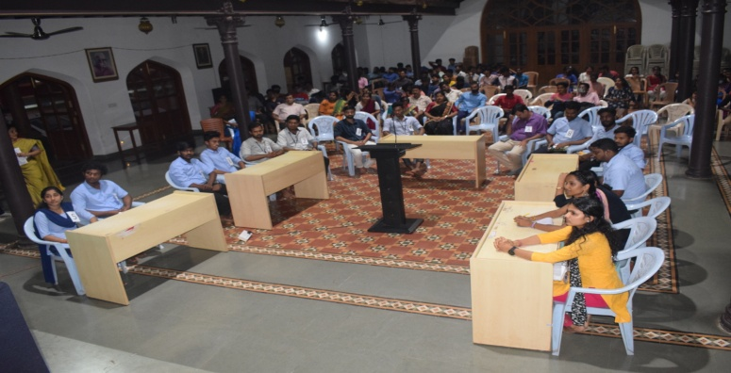  ¥ÀæeÁ¥Àæ¨sÀÄvÀé ZÀÄ£ÁªÀuÁ ªÀåªÀ¸ÉÜAiÀÄ°è ¸ÀÄzsÁgÀuÉUÀ¼ÀÄ- «zÁåyðUÀ¼ÉÆA¢UÉ ZÀZÁð PÀÆl | 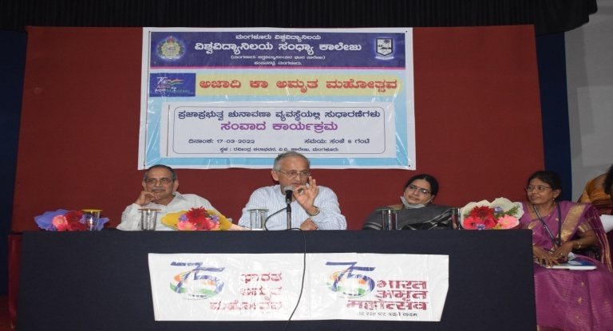  ¥ÀæeÁ¥Àæ¨sÀÄvÀé ZÀÄ£ÁªÀuÁ ªÀåªÀ¸ÉÜAiÀÄ°è ¸ÀÄzsÁgÀuÉUÀ¼ÀÄ- ¸ÀAªÁzÀ PÁAiÀÄðPÀæªÀÄ
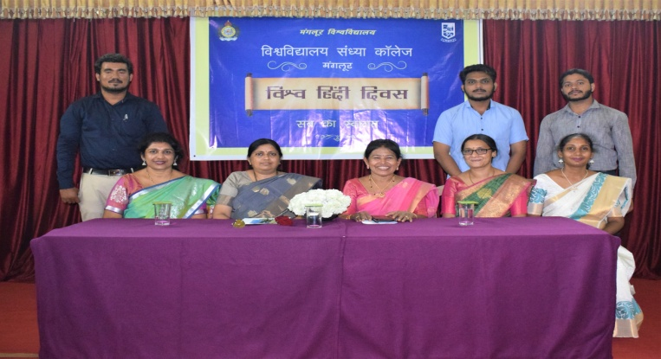  «±Àé »A¢ ¢£ÁZÀgÀuÉ PÁAiÀÄðPÀæªÀÄ | 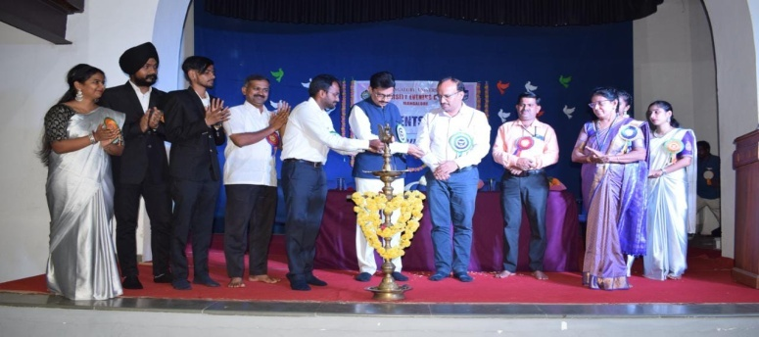  «zÁåyð ¸ÀAWÀzÀ GzÁÏl£Á PÁAiÀÄðPÀæªÀÄ- 2022
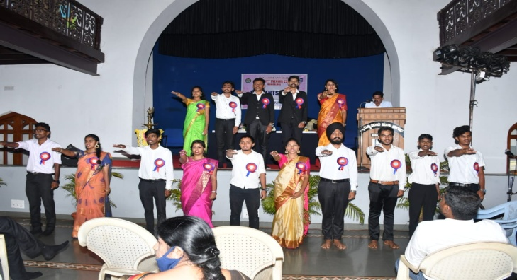  «zÁåyð ¸ÀAWÀzÀ ¸ÀzÀ¸ÀågÀ ¥ÀæªÀiÁt ªÀZÀ£À ¹éÃPÁgÀ | 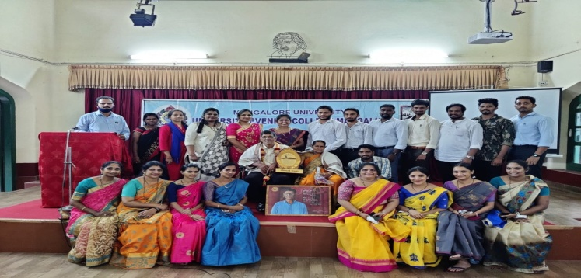  ¸ÀAzsÁå PÁ¯ÉÃdÄ PÀbÉÃjAiÀÄ £ËPÀgÀgÁzÀ ²æÃ.£ÁUÉÃ±ïgÀªÀgÀ ©Ã¼ÉÆÌqÀÄUÉ ¸ÀªÀiÁgÀA¨sÀ
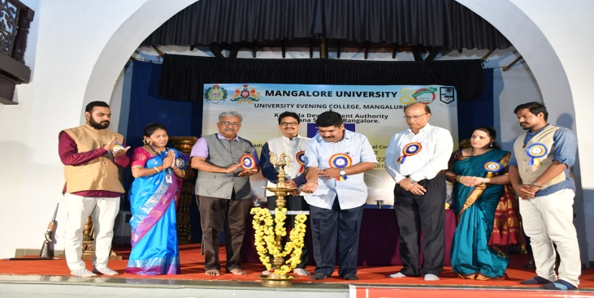  gÁ¶ÖçÃAiÀÄ «ZÁgÀ ¸ÀAQgÀt GzÁÏl£Á PÁAiÀÄðPÀæªÀÄ | 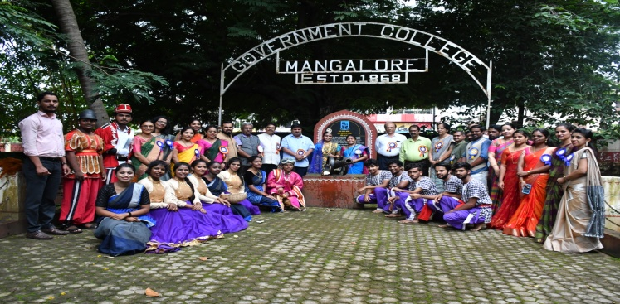  «.«.PÁ¯ÉÃdÄ DªÀgÀtzÀ°ègÀÄªÀ ¸ÁévÀAvÀæöå ¥ÀÆªÀðzÀ ¦ügÀAV ¸ÁägÀPÀzÀ°è C§âPÀÌ gÁtÂAiÀÄ gÀÆ¥ÀPÀ vÀAqÀ
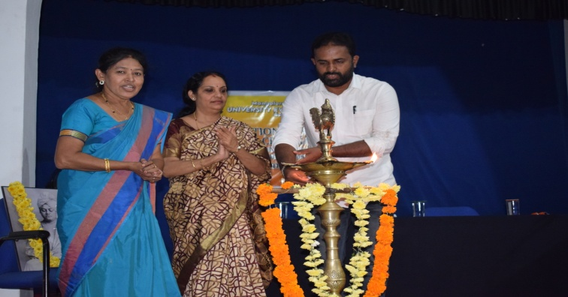  gÁ¶ÖçÃAiÀÄ AiÀÄÄªÀ ¢£ÁZÀgÀuÉ | 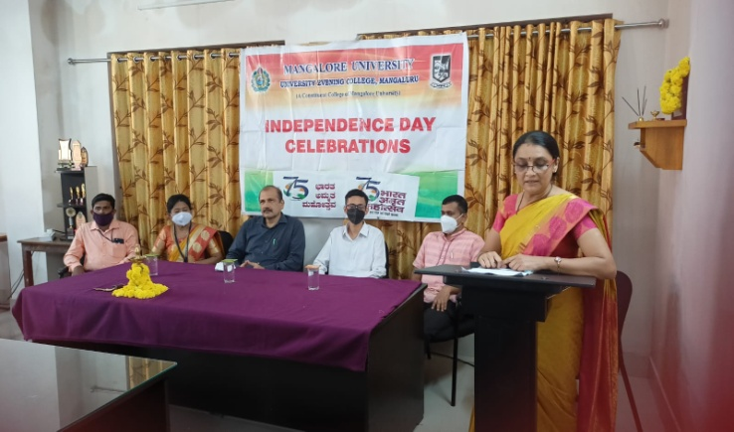  75£ÉÃ ¸ÁévÀAvÀæöå ¢£ÁZÀgÀuÉAiÀÄ PÁAiÀÄðPÀæªÀÄ
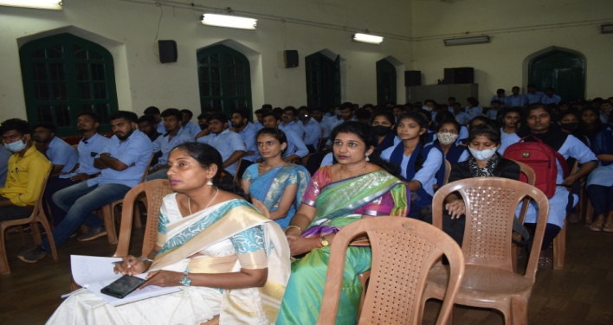  gÁ¶ÖçÃAiÀÄ AiÀÄÄªÀ ¢£ÁZÀgÀuÉAiÀÄ PÁAiÀÄðPÀæªÀÄzÀ°è ¥Á¯ÉÆÎArgÀÄªÀ «zÁåyðUÀ¼ÀÄ | 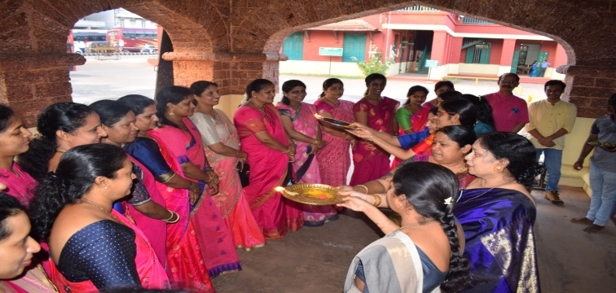  ªÀÄ»¼Á ¢£ÁZÀgÀuÉAiÀÄ PÁAiÀÄðPÀæªÀÄ

